Lithium Chloride Treatment of Axolotl Embryos

Lithium causes developmental abnormalities due to its ability to inhibit glycogen synthase kinase-ß (ventralizing signal - initiates wnt gene) which initiates developmental pathways.

Lithium treatment results in dorsalized embryos (so extra head-end tissue, not tail-end tissue). This can cause expansion of dorsal and anterior structures, sometimes yielding 2 heads and bifurcated spinal column.

Dorsalization is when the dorsal blastopore lip forms around the entire embryo at the same time. The result is an embryo that has a continous doral side. The most extreme results of this treatment are embryos with radial symmetric heads, a cylindrical heart, and bands of eye pigment. (Sive et al. 2000) This event occurs at the same time in development that the dorsal blastopore lip would form if there had been no lithium chloride treatment administered.

PROTOCOL

- De-jelly early blastula embryos before the 32 cell stage.

a) Select and separate embryos below the 32 cell stage,

b) Remove jelly membrane using sharpened forceps.

c) Place de-jellied embryos in 20% Steinberg's solution (or Holtfreter’s).

d) Select embryos that remain below or at the 32 cell stage.

2. Rinse healthy embryos and transfer 3/4 to the experimental petri dish containing 0.3M lithium chloride in 0.1x MBS. Transfer the remaining embryos to a control petri dish with 10% Steinberg's solution.

6.36g LiCl in 500ml of .1X MBS

MBS=Modified Barth’s Solution
In 500 ml:

2.57g NaCl  0.037g KCl  0.023g CaCl2  0.039g Ca(NO3)2 (calcium nitrate)  0.101g MgSO4 x 7H2O | 0.101g NaHCO3 (sodium bicarbonate)  1.19g HEPES (buffer)  pH adjust to 7.4  Sterile Filter and store at 15C

3. Gently mix solution and embryos.
4. Incubate embryos at 18-20˚C for 10 minutes.
5. Rinse incubated embryos and transfer to petri dish with 20% Steinberg's solution.
6. Incubate embryos at 18-20C and score perturbations at early gastrula.

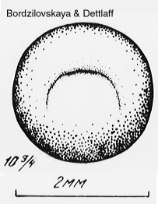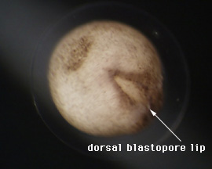
Holtfreter's Solution

100% Holtfreter's solution Check pH; should be between 7 and 7.5

NaCl 3.5 g
NaHCO₃ 0.2 g
KCl 0.05 g
MgSO4 stock solution 333 µl
CaCl₂ stock solution 333 µl
DH₂O 1 liter

50% Holtfreter's solution for older embryos, larvae, and adults Check pH; should be between 7.4

 | flask | carboy | trash can
NaCl | 1.75 g | 35 g | 262.5 g
NaHCO₃ | 0.1 g | 2g | 15g
KCl | 0.025 g | 0.5 g | 3.75 g
MgSO₄ stock solution | 335 µl | 6.66 ml | 50 ml
CaCl₂ stock solution | 335 µl | 6.66 ml | 50 ml
dH₂O | 1 liter | 20 liters | 150 liters

------------------------------------------------------------------------
MgSO₄ stock solution
Combine:
300 g MgSO₄
500 ml deionized water

CaCl₂ stock solution
Combine:
150 g CaCl₂
500 ml deionized water
------------------------------------------------------------------------
Source: based on Armstrong, J.B., Duhon, S.T., and Malacinski, G.M. (1989) Raising the axolotl in captivity. In J.B. Armstrong and G.M. Malacinski (eds.) Developmental Biology of the Axolotl. New York: Oxford University Press, pp. 220-227.

