Axolotl Fact Sheet

Axolotls (Ambystoma mexicanum) are an endangered species. They are listed in the CITES Appendix II listing of endangered species and are subject to trade restrictions internationally. Nationally, they are also subject to state-by-state restrictions in trade.

Axolotls are indigenous to one lake near Mexico City, Lake Xochimilco. There are not many left, hence their endangered status. This has happened for 3 main reasons: a) non-native predators have been introduced to their environment; b) habititat reduction; c) pollution.

 | Axolotls are unusual because they are neotenic, which means they reach adulthood or sexual maturity while still in the larval (aquatic) form. |  | 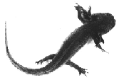
 | 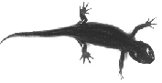 |  | There is no phase in their natural life cycle in which they metamophose into the terrestrial salamander form. However, under certain conditions, some animals will undergo this metamophosis.

Ambystoma mexicanum (terrestrial form) | A very close relative to the axolotl (Ambystoma mexicanum) is the tiger salamander (Ambystoma tigrinum), found all over North America, including Indiana. | Ambystoma tigrinum

Axolotls reach sexual maturity anywhere from 9 months to 2 years,
depending on environmental factors and genetics.

 | 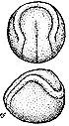 |  |  | Embryos, or fertilized eggs, take 2 weeks to hatch at room temp-erature (72°F, 23°C). Embryos can be cooled in order to slow down development and delay hatch up to 2 months.

 | Axolotls have several pigment variations,  primarily dark, white, and albino. | 